**DSA Lab Task (10, 11, 12, 13)**

**Name:**

**Hamza Naeem**

**Roll No:**

**052**

**Dept:**

**Software Engineering**

Output (10)

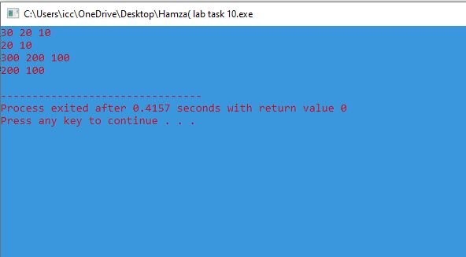

Output (11)

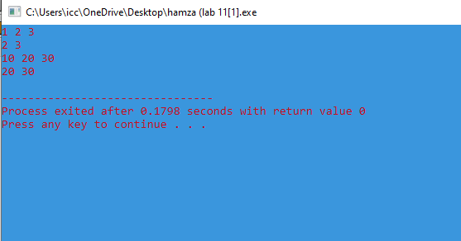

Output(12)

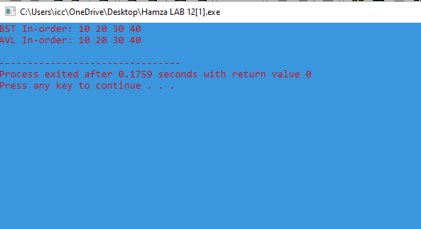

Output (13

